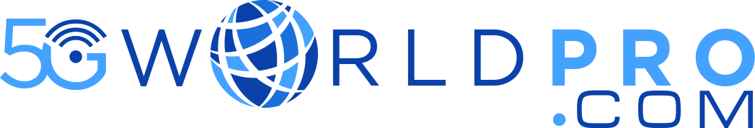

## **5G FRMCS Training**

The **FRMCS over 5G** course offers a comprehensive technical journey into the evolution of railway communication systems as they transition from legacy GSM-R to a future-ready, 5G-based architecture. This training is designed to equip telecom professionals, railway engineers, and system integrators with the knowledge needed to understand, plan, and implement the **Future Railway Mobile Communication System (FRMCS)** in alignment with 3GPP standards and industry requirements.

The course begins with a strategic overview of why the shift from GSM-R is essential—highlighting the growing needs for **high-speed connectivity**, **low-latency communication**, and **scalable services** in modern rail operations. Participants are then guided through the **end-to-end FRMCS system**, with a strong focus on **5G architecture**, **QoS mechanisms**, and **service-based interactions** that enable mission-critical communication in fast-moving railway environments.

**Duration : 2 Days Training**

**Module 1: Reimagining Railway Communications – From GSM-R to FRMCS**

* Limitations of GSM-R: spectrum constraints, circuit-switched dependency, and limited data capacity.
* Drivers for change: automation, predictive maintenance, high-speed data needs, and ERTMS evolution.
* FRMCS vision and role in supporting digital railways and autonomous train operations.
* Key stakeholders and global initiatives backing FRMCS development.
* Introduction to key use cases: train-to-ground video streaming, real-time diagnostics, and remote driver communications.

**Module 2: 5G System Fundamentals Tailored for Railways**

* Introduction to 5G system design and evolution from LTE.
* Core components of the 5G architecture relevant to FRMCS (AMF, SMF, UPF, PCF).
* SBA (Service-Based Architecture) and RESTful API exposure for railway applications.
* Functional overview of the IMS system and its role in delivering voice/video over IP.
* C-RAN and gNB-DU/ gNB-CU split concepts for centralized rail deployments.

**Module 3: FRMCS UE Registration, Session Management, and QoS**

* Detailed registration signaling flow for train-mounted UEs.
* How PDU sessions are set up for MCPTT, MCData, and MCVideo.
* Deep dive into 5QI values, ARP levels, and GBR/non-GBR mapping for rail services.
* Dynamic QoS modification during handovers and emergency broadcasts.
* Network slicing tailored to rail functions: operational, safety, and passenger slices.
* Authentication, authorization, and integrity assurance in FRMCS.

**Module 4: FRMCS and 5G Radio Layer Design**

* Frequency bands allocated for FRMCS (e.g., 874–876 MHz, 915–917 MHz).
* Duplexing modes: TDD vs. FDD for rural and dense metro corridors.
* Overview of 5G NR numerology and its impact on high-speed rail mobility.
* Frame structure and slot configuration recommendations for latency-sensitive rail apps.
* Practical coexistence strategies for GSM-R and FRMCS during the transition phase.

**Module 5: Integrating Applications and APIs in Railway Networks**

* FRMCS application layer: dispatcher systems, CCTV uplink, data acquisition.
* Key interface points: APIs between NEF and third-party control systems.
* Network exposure strategies for predictive analytics, monitoring platforms, and emergency alerts.
* How to expose real-time location, service availability, and diagnostic data to control centers.
* Introduction to MEC (Multi-access Edge Computing) and edge placement in rail environments.

**Module 6: Mission-Critical Services and Group Communication Over 5G**

* Architecture of MCx services and how they fulfill railway safety requirements.
* Setup of group communication for emergency and daily operational calls.
* Proximity-based communication using ProSe in tunnel and rural conditions.
* Multicast and broadcast (MBS) to disseminate information to multiple rail subsystems.
* Integration of MCPTT with emergency braking, train control, and alerting systems.

**Module 7: Operational Considerations and Deployment Challenges**

* Migration planning from GSM-R to FRMCS: phased vs. overlay models.
* Interoperability testing, pilot project frameworks, and KPI definition.
* Performance monitoring: jitter, latency, packet loss benchmarks for mission-critical flows.
* Real-time network adaptation to rail mobility patterns (handover frequency, signal blocking zones).
* Ensuring redundancy and availability in harsh environments.

**Module 8: Future Roadmap and Industry Trends**

* Review of 3GPP Release 17/18 features relevant to FRMCS.
* Integration with 6G and beyond: ultra-reliable, low-latency evolution.
* AI/ML in rail communications: anomaly detection, autonomous maintenance triggers.
* Edge intelligence and orchestration of rail slices.
* Emerging global deployments and spectrum harmonization efforts.